DIR Fundamentals

November 15th through 17th at the Blue Hole in Santa Rosa, New Mexico.

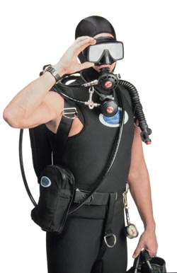
Are you a recreational diver or underwater photographer that wants to finely hone your skills and equipment to make diving easier, safer and more fun? Or a technical or budding technical diver that wants to make sure that your technical skills are honed to the point that you can handle severe task loading with a minimum of effort and a maximum of safety? If so, you should consider this course.

DIR is the acronym for “Do It Right”, a SCUBA diving approach that encompasses many facets including diving equipment, skills, fitness, methodologies and buddy awareness that improve a diver’s safety and enjoyment of the sport. The Woodville Karst Plain Project (WKPP) is credited with pulling together and refining existing diving techniques and approaches to make up the cohesive DIR philosophy required to accomplish their cave exploration that currently stands at a three mile penetration into Wakulla Spring in Florida at a depth of 300 feet.

Though DIR’s roots lie in the technical cave community, it can be applied seamlessly to recreational diving as well. You needn’t dive double cylinders and a canister light in order to enjoy the benefits of the DIR approach to diving. Though the equipment aspect of DIR is clearly the most visible, like an iceberg, the equipment is only the most noticeable component of the DIR system.

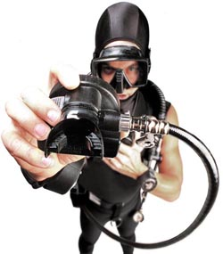
The class size and teacher/student ratio is small and training is tailored to each and every diver. Skills taught and focused on depend on each diver’s skill level, goals and equipment. Equipment configuration, manipulation and problem solving will be practiced in order to improve the diver’s skill set, from a recreational diver’s single AL80 to a caver’s or decompression diver’s twin steel 104s, canister light and reels/spools. All divers will be videotaped and critiqued later to afford immediate feedback to accelerate learning and skill acquisition.

The DIR Fundamentals course is offered through Global Underwater Explorers (GUE), the only agency actively and exclusively teaching the DIR system. GUE Training Director Andrew Georgitsis will be teaching the course accompanied by GUE instructors Michel Kane and Sonya Tittle.

Cost of the course is $300; a $100 deposit is required with the balance due October 15th. For more information contact Roger Oakey (719-332-9085 / roakey@underctek.com) or Sonya Tittle (888-854-3483 / sonya@fifthd.com) or see the links below. To sign up for the course please contact Roger Oakey.

Please note that the DIRF course is a prerequisite to taking any GUE cave or technical class.

GUE | http://www.gue.com/
About DIR | http://www.dirquest.com/about_dir.shtml, http://www.fifthd.com/h2oadventuregear/productinfo/dirphilo.htm - more cave oriented
Course outline and requirements | http://www.gue.com/classroom/standards/gue_rec_student.pdf, http://www.fifthd.com/divestore/classes/Fundamentals.htm
DIRF class discussion on the web | http://www.scubaboard.com/t13471/s.html, http://www.scubaboard.com/t13618/s.html, http://www.scubaboard.com/t12361/s.html, http://www.scubaboard.com/t11998/s.html
WKPP | http://www.wkpp.org/

This document & links available online at http://www.underctek.com/open/DIRF/dirf.html
What students are saying about DIR Fundamentals on the web:

Would I recommend it to a friend? DEFINATELY. I learned more in this class than any other dive course I've taken. And I've taken classes through PADI, YMCA, TDI, and IANTD.

--www.diverlink.com’s “PattyG”

As far as bang for the buck goes this is one of the best. Except from my original OW class which taught me all the basic skills, and perhaps my cave class, no other class that I have taken has given me as much knowledge and as many tools to improve my overall diving as the DIRF class did.

-- www.scubaboard.com’s “Cave Diver”

One of the benefits of GUE classes is getting to talk with instructors of surpassing skill, who have dove in some of the most challenging environments possible.

--www.scubaboard.com’s “Fetch”

… don’t be apprehensive about the class based on what you have heard on the Internet or put it off because you don’t think you are ready…take it. There are a lot of misconceptions about DIR and GUE floating around the ‘net, and everything will be cleared up in the class. Definitely the most bang for your buck in dive education that I have been a part of. You won’t regret it.

--www.scubaboard.com’s “O-ring”

So after 2 ½ days of this course, am I a better diver? Absolutely not. But more importantly, I feel like I now have some tools that I can start actively using on every dive to make myself a more skilled and safer diver and buddy – which is what DIR is all about.

--www.scubadiving.com’s “large_diver”

… this class was nothing less than mind boggling. I have greater respect than ever before for what GUE is trying to do, how they do it, and why.

--www.scubaboard.com’s “Lost Yooper”

